Welcome To Our Worship

Gathering Together

Knock. Knock.
Who’s there?
The one who comes in the name of the Lord. Hosanna in the the highest.

People’s Prayer / Lord’s Prayer

Hearing Together

John 20:19-29
When it was evening on that day, the first day of the week, and the doors of the house where the disciples had met were locked for fear of the Jews, Jesus came and stood among them and said, “Peace be with you.” After he said this, he showed them his hands and his side. Then the disciples rejoiced when they saw the Lord.

Jesus said to them again, “Peace be with you. As the Father has sent me, so I send you.” When he had said this, he breathed on them and said to them, “Receive the Holy Spirit. If you forgive the sins of any, they are forgiven them; if you retain the sins of any, they are retained.”

But Thomas (who was called the Twin), one of the twelve, was not with them when Jesus came. So the other disciples told him, “We have seen the Lord.” But he said to them, “Unless I see the mark of the nails in his hands, and put my finger in the mark of the nails and my hand in his side, I will not believe.”

A week later his disciples were again in the house, and Thomas was with them. Although the doors were shut, Jesus came and stood among them and said, “Peace be with you.” Then he said to Thomas, “Put your finger here and see my hands. Reach out your hand and put it in my side. Do not doubt but believe.” Thomas answered him, “My Lord and my God!” Jesus said to him, “Have you believed because you have seen me? Blessed are those who have not seen and yet have come to believe.”

Receiving Together:

“The pope, a rabbi, and a lawyer” - Rev. Ian Macdonald

Closing prayer

Benediction

Name 3 ways God has made you laugh lately:

“Those who seek the Lord will lack no good thing.”

Thank you for being a part of today’s service.

It is always our intention to make you feel welcomed and at home. We hope we were able to achieve this and that you will continue to participate in our mission and vision:

- Love God.
- Love Others.
- Serve Both

Your financial support is imperative to the success of this ministry. Please visit our website and make a generous donation today. www.newchurchshermanoaks.org

Sunday Worship: 11:00 – 11:30 am
Streaming Live on Facebook

New Church Sherman Oaks is a unique internet/home church hybrid. As fancy as that might sound we are simply a gathering of ordinary people trying to build up our faith in God and live it out in a way that is relevant and purposeful for the building up of God’s Kingdom. We invite you embrace this Spirit and make our home your New Church home.

WELCOME TO

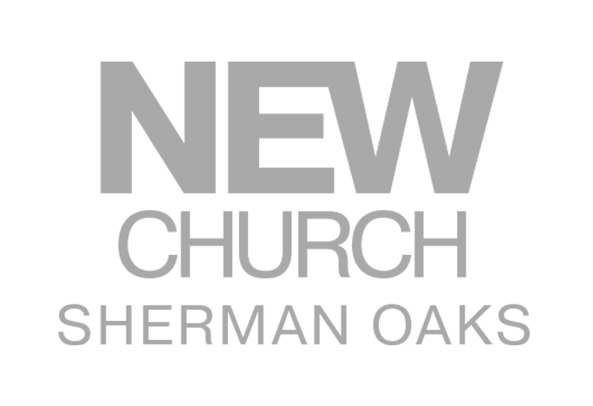

April 28, 2019

