Welcome To Our Worship

Gathering Together

The Mighty One, God the Lord, the perfection of beauty, let your light shine forth.
Our God, does not keep silent, He calls to the heavens above and to all His creation.

Gather us, your faithful ones, so we might receive your Spirit.
By your sacrifice you made a covenant with us. By your Word we will walk humbly with you in love and righteousness for all the days of our lives, Amen.

People’s Prayer / Lord’s Prayer

Hearing Together

John 13:31-35
When he had gone out, Jesus said, “Now the Son of Man has been glorified, and God has been glorified in him. If God has been glorified in him, God will also glorify him in himself and will glorify him at once. Little children, I am with you only a little longer. You will look for me; and as I said to the Jews so now I say to you, ‘Where I am going, you cannot come.’ I give you a new commandment, that you love one another. Just as I have loved you, you also should love one another. By this everyone will know that you are my disciples, if you have love for one another.”
Receiving Together:

“Walk the Walk”
- Rev. Ian Macdonald

“Do not think that I have come to abolish the law or the prophets, I have not come to abolish but to fulfill.”
~ Jesus the Christ

Closing prayer

Benediction

Reflecting Together:

“He has told you, O mortal, what is good;
and what does the Lord require of you
but to do justice, and to love kindness,
and to walk humbly with your God?
(Micah 6:8)

In what ways do you show:
Justice:_______________________________________________________________
Kindness:____________________________________________________________
Humility:_____________________________________________________________

Thank you for being a part of today’s service.

It is always our intention to make you feel welcomed and at home. We hope we were able to achieve this and that you will continue to participate in our mission and vision:

- Love God.
- Love Others.
- Serve Both

Your financial support is imperative to the success of this ministry. Please visit our website and make a generous donation today. www.newchurchshermanoaks.org

Sunday Worship: 11:00 – 11:30 am
Streaming Live on Facebook

New Church Sherman Oaks is a unique internet/home church hybrid. As fancy as that might sound we are simply a gathering of ordinary people trying to build up our faith in God and live it out in a way that is relevant and purposeful for the building up of God’s Kingdom. We invite you embrace this Spirit and make our home your New Church home.

WELCOME TO

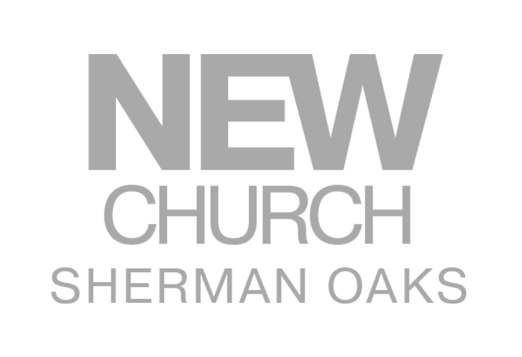

May 19, 2019

